An Internship Report
Of

DATA SCIENCE WITH PYTHON

Submitted
To
School of Computer Science and Engineering
IILM University, Greater Noida, U.P.

In partial fulfilment of the requirement of degree of
B-Tech (CSE)



By

Roll Number of Student:- 25SCS1003004887
Name of Student: Vikram Adhikari

Batch: 2026-27

CANDIDATE'S DECLARATION
I, Vikram Adhikari, student of Bachelor of Technology in Computer Science and Engineering, Semester III, Section 2CSE11, Roll No. 25SCS1003004887, hereby declare that the internship report titled “Data Science with Python” is based on the work and learning completed by me during my internship with Beeskilled. I further declare that this report has been prepared for academic purposes and that the project results presented in the final-project section are based on the actual Google Colab notebook used for the Titanic analysis.
Signature:-

Student Name: Vikram Adhikari

Roll No.: 25SCS1003004887

ACKNOWLEDGEMENT
I would like to express my sincere gratitude to Beeskilled for providing me with the opportunity to undertake an internship in the field of Data Science with Python. The internship gave me valuable practical exposure to data analysis, visualization, and machine learning concepts.
I am thankful for the project-based learning activities and resources provided during the internship. Working with different datasets helped me understand how raw data can be cleaned, explored, visualized, and interpreted using Python.
I would also like to thank my institute and faculty members for their guidance and support during the internship and the preparation of this report. Finally, I am grateful to everyone who supported me directly or indirectly throughout this learning experience.
Signature:

Student Name: Vikram Adhikari

Roll No.: 25SCS1003004887

TABLE OF CONTENTS
1. Candidate's Declaration i
2. Acknowledgement ii
3. Internship Completion Certificate -
4. Project Description 1
4.1 Introduction 1
4.2 Organization Profile 2
4.3 Problem Statement 3
4.4 Project Objectives 3
4.5 Scope of the Project 4
4.6 Technologies and Tools Used 4
4.7 System Architecture 5
4.8 Methodology 6
4.9 Expected Outcomes 7
5. Bibliography/References 8
3. INTERNSHIP COMPLETION CERTIFICATE
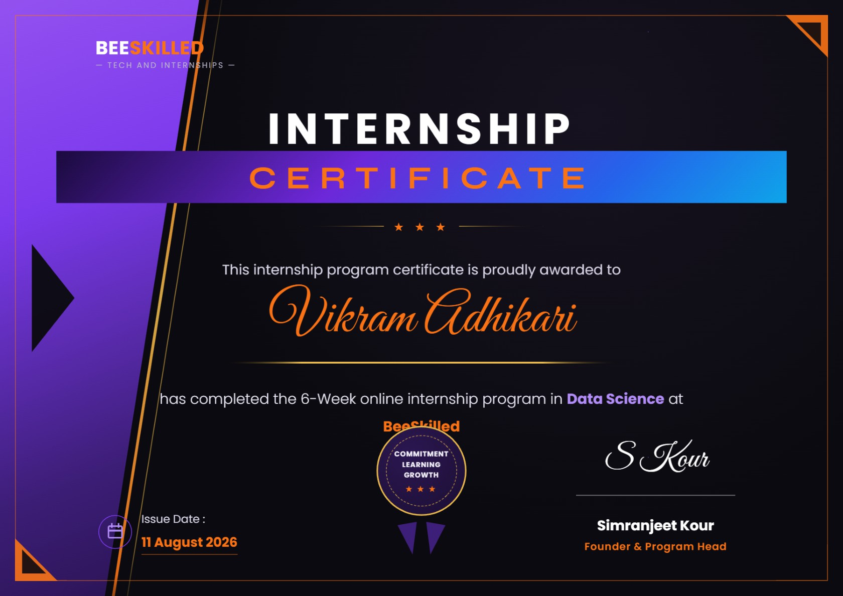

Internship Offer Letter
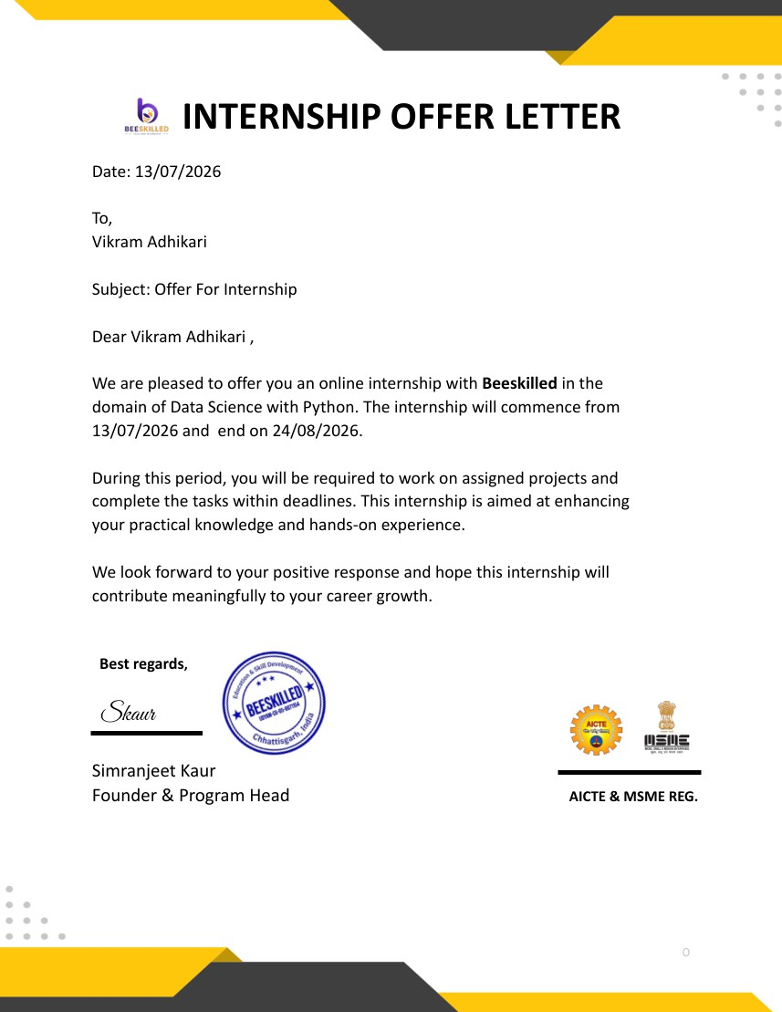

4. PROJECT DESCRIPTION

4.1 Introduction
This report presents a detailed account of the internship undertaken with Beeskilled in the domain of Data Science with Python. According to the internship offer letter, the online internship commenced on 13 July 2026 and ended on 24 August 2026. The internship was intended to enhance practical knowledge and hands-on experience through assigned projects and tasks.
The learning activities followed a progressive path. The first stage introduced Python for Data Science through analysis of a Student Marks Dataset. The second stage focused on exploratory data analysis and visualization using COVID-19 data. The third stage introduced machine learning through student performance prediction using Linear Regression. The final project applied the learned techniques to the Titanic Dataset.
The completion certificate recognizes the successful completion of a six-week online internship in Data Science. The final project presented in this report is the Titanic Dataset Analysis performed in Google Colab.

4.2 Organization Profile
Beeskilled provided an online internship in the field of Data Science with Python. The internship structure emphasized practical learning through assigned projects and tasks. The activities exposed the learner to data handling, visualization, exploratory analysis, and introductory machine learning.
The internship used common Python data-science tools including Pandas, NumPy, Matplotlib, Seaborn, and Scikit-learn. Project-based tasks allowed the concepts to be applied to different datasets rather than being limited to theoretical study.

4.3 Problem Statement
The main problem addressed during the internship was to develop practical competence in the Data Science workflow using Python. Understanding concepts theoretically is not sufficient; practical work is required to learn how datasets are loaded, cleaned, analyzed, visualized, and used for prediction.
The internship therefore progressed from basic data analysis to visualization and machine learning. The final project required these skills to be applied to the Titanic Dataset in order to identify differences in passenger survival outcomes.

  - Project Objectives
- Understand the fundamentals of Data Science using Python.
- Work with datasets using Pandas and NumPy.
- Perform basic data cleaning and preprocessing.
- Calculate and interpret basic statistics.
- Create data visualizations using Matplotlib and Seaborn.
- Perform Exploratory Data Analysis (EDA).
- Understand introductory Machine Learning concepts.
- Apply Linear Regression using Scikit-learn.
- Analyze the Titanic Dataset and identify survival-related patterns.
- Develop practical analytical and problem-solving skills through projects

4.5 Scope of the Project
The scope of the internship covered the fundamental stages of Python-based Data Science: data loading, cleaning, exploratory analysis, visualization, and introductory machine learning. The weekly work used multiple datasets to build skills progressively.
The final project focused specifically on Titanic survival analysis. The project included data inspection, handling missing values, creating derived features, comparing survival rates across passenger characteristics, and visualizing the results.

  - Technologies and Tools Used

Technology / Tool | Use in Internship
Python | Primary programming language for analysis.
Pandas | Data loading, cleaning, transformation, grouping and analysis.
NumPy | Numerical operations and data processing.
Matplotlib | Data visualization and plotting.
Seaborn | Statistical and categorical visualizations.
Scikit-learn | Introductory machine-learning work, including Linear Regression.
Google Colab | Notebook environment used for the final Titanic project.

4.7 System Architecture
The overall Data Science workflow followed during the internship can be represented as:
Data Collection → Data Loading → Data Cleaning → Exploratory Data Analysis → Visualization →
Model / Analysis → Results & Interpretation

Data Collection: Relevant datasets were selected for each project. Data Loading: Python tools were used to read the datasets. Cleaning: Missing and unsuitable values were handled. EDA: Patterns and relationships were explored. Visualization: Graphs were used to communicate findings. Analysis / Model: Statistical grouping or machine-learning methods were applied. Interpretation: Results were summarized as meaningful findings.

4.8 Methodology
The internship followed a structured, week-wise methodology combining conceptual learning, hands-on labs, weekly assessments, and project submissions, as summarized in the table below.
Week | Module | Description
1 | Python for Data Science Basics & Student Marks Analysis | Introduction to Python for Data Science, Pandas and NumPy. Worked with the Student Marks Dataset and performed basic data cleaning, statistical calculations, and data analysis.
2 | Data Visualization & Exploratory Data Analysis | Worked with the COVID-19 Dataset using Matplotlib and Seaborn. Created visualizations such as trend plots, country comparisons, heatmaps, and scatter plots to identify patterns in the data.
3 | Machine Learning & Student Performance Prediction | Introduction to Machine Learning using Scikit-learn. Used the Student Performance Dataset to understand data preparation, model training, Linear Regression, and model evaluation.
4 | Final Project – Titanic Dataset Analysis | Performed complete analysis of the Titanic Dataset using Python and Google Colab. Included data cleaning, missing-value handling, feature creation, survival analysis by gender, class, age, embarkation point and family size, along with data visualization.

Each week concluded with a weekly assessment to evaluate conceptual understanding, and selected modules required submission of project documentation and assignments. In the final week, a Final Assessment Test was conducted, and the overall grade was based on performance across weekly assessments, project submissions, and the final test.

4.9 Expected Outcomes
The internship was expected to develop practical understanding of the Data Science workflow and familiarity with commonly used Python libraries. The project-based approach was intended to improve data cleaning, analysis, visualization, and introductory machine learning skills.
The completed work demonstrates practical experience in handling structured datasets, performing grouped analysis, generating visualizations, and interpreting results. The final Titanic project provides the strongest evidence of the application of these skills.

5. BIBLIOGRAPHY/REFERENCES
- Beeskilled Internship Offer Letter – Data Science with Python.
- Beeskilled Internship Completion Certificate – Data Science.
- Beeskilled Week 1 learning material – Python for Data Science Basics / Student Marks Dataset.
- Beeskilled Week 2 learning material – Data Visualization / COVID-19 Dataset.
- Beeskilled Week 3 learning material – Machine Learning Introduction / Student Performance Prediction.
- Beeskilled Week 4 learning material – Final Data Analysis Project / Titanic Dataset.
- Author's Google Colab notebook – Titanic Dataset Analysis, containing the project code, outputs and visualizations.

